Assessing potential sources of bias in measuring power outage exposure with simulations supplement

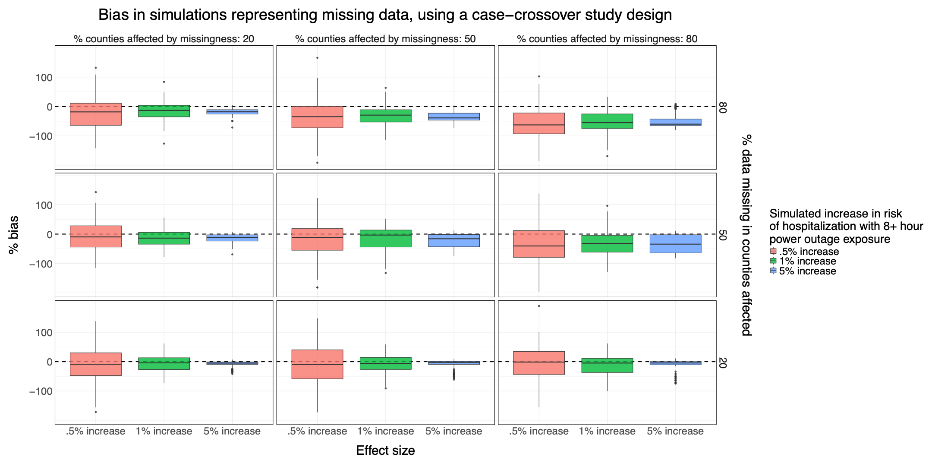
Supplement Figure 1: Results from simulations of the association between power outage exposure and hospitalizations in 100 counties with different percentages of exposure data missing, using a case-crossover design. Simulations were repeated 100 times, and boxplots show the distribution of the percent bias of effect estimates in each simulation scenario. There is a dashed line at 0.
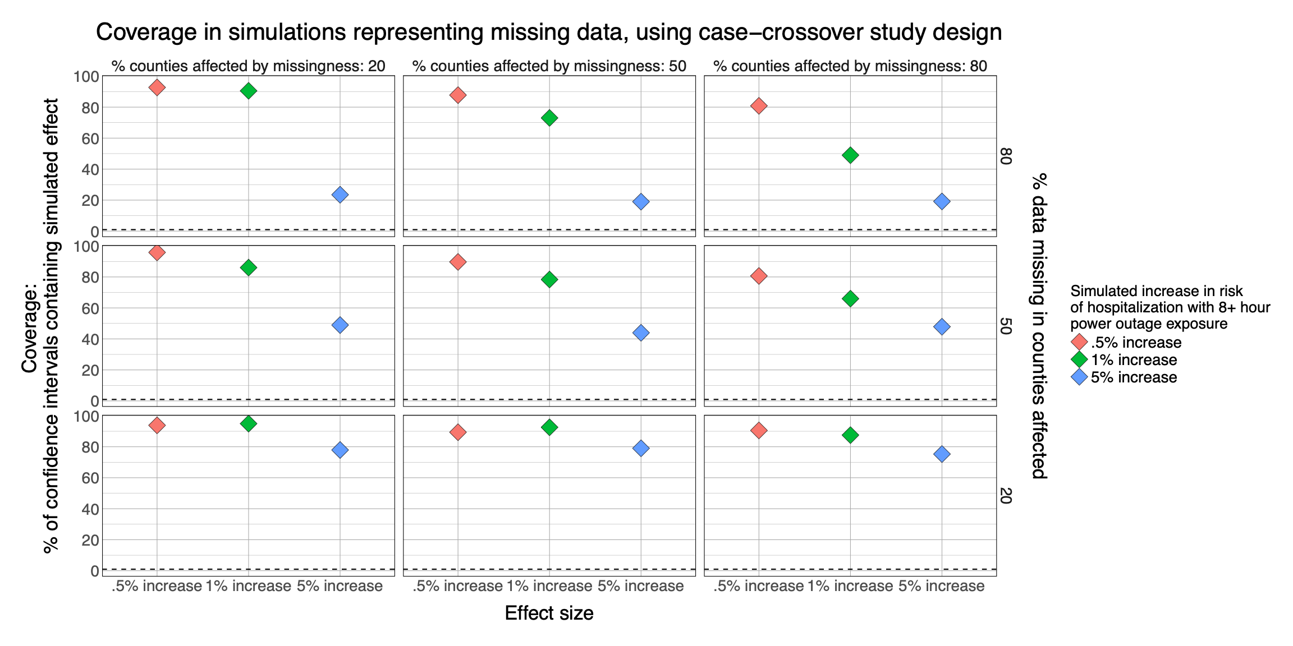
Supplement Figure 2: Results from simulations of the association between power outage exposure and hospitalizations in 100 counties with different percentages of exposure data missing using a case-crossover design. Simulations were repeated 100 times, and plots show the percent coverage of 95% confidence intervals. There is a dashed line at 95%

Supplement Table 1: Results from simulations of the association between power outage exposure and hospitalizations in 100 counties for exposure misclassification scenarios representing wrong assumptions about the health-relevant duration of power outage, for a (A) difference-in-differences design, and (B) case-crossover design. Simulations were repeated 100 times.

Table 1A: Results from difference-in-differences study design simulations. Average percent bias (standard deviation of bias); coverage.
Effect size | No exposure misclassification | Exposure misclassification: 8+ hour exposure instead of 4+ hour | Exposure misclassification: 8+ hour exposure instead of 12+ hour
0.5% | -11.5% (72.1); 93% | -10.6% (57.6); 98% | -63.8% (70.6); 76%
1% | 2.3% (30.3); 95% | -6.7% (30.6); 96% | -64.7% (34.9); 46%
5% | -2.5% (5.8); 96% | -8.1% (7); 68% | -68.2% (9.2); 0%

Table 1B: Results from case-crossover study design simulations. Average percent bias (standard deviation of bias); coverage.
Effect size | No exposure misclassification | Exposure misclassification: 8+ hour exposure instead of 4+ hour | Exposure misclassification: 8+ hour exposure instead of 12 hr
0.005 | -3.4% (49.6); 93.8% | -9.4% (48.4); 93.5% | -72.1% (47.9); 58.9%
0.01 | -0.7% (22.1); 95.9% | -7.5% (21.4); 95.8% | -69% (24.1); 15.5%
0.05 | -2.6% (3.8); 93.8% | -11.1% (4.5); 30.9% | -69.1% (7.6); 0%

